Unveiling Cultural Heritages with Professor Kisha Tracy at Fitchburg State University

A few years ago, Professor Tracy was looking to rework her World Literature and Writing II classes because she wasn’t satisfied with the format or the available subject matter. In light of what was happening in Syria around that time, Dr. Tracy began thinking about various concepts of cultural heritage and how we understand and appreciate our heritages and the heritages of others. With these ideas in mind, she began crafting the first two weeks of her courses to demonstrate to students why studying the selected material was important.

Dr. Tracy firmly believes that explaining to students why what they study matters is integral to developing authentic engagement in the classroom. With research focuses in Medieval World Literature and Chaucerian Middle English, she acknowledges that it is very easy for students to dismiss the significance of texts from these periods. “But there are several angles of pursuit to explain why what happened during the Middle Ages still matters today,” Tracy says. Issues with proper gender and disability representation or our very new and complicated experiences with COVID-19 are two apt examples of social circumstances that mirror those of the Medieval times.

Therefore, Tracy developed a project with her upper-level Middle Ages students where they take one piece of literature from the syllabus, discuss what cultural heritage it relates to and how, relate it to another piece of cultural heritage from its time period or area, and triangulate it with a piece of cultural heritage from modern-day New England. This multi-faceted project spans the entire semester and asks that students discover local direct connections or local abstract connections and realize that cultural heritage is not constrained by time.

What began as a Cultural Heritage through Image project blossomed into Heritages of Change. In her Gen-Ed Writing II course, Dr. Tracy wanted her students to understand that all writing has a purpose and an audience. Heritages of Change is essentially a mini-exhibition project where students first learn about principles of curatorial activism; the awareness that within preservation sites, like museums, there are topics that are marginalized. Students are then provided a list of umbrella topics to choose from, such as disabilities, race, gender, and sexuality, decide which one they’d like to focus on, and write extensively about that topic throughout the entire semester.

Dr. Tracy decided to have the Adult Learning in the Fitchburg Area group (ALFA) serve as a tangible audience for her students to think about when crafting their exhibition essays. “They absolutely adore the students,” Tracy smiles. “They always have a great time interacting with them.” Student work is displayed the following spring semester and the FSU community and beyond are welcomed to visit the exhibits. Individuals who see all of them win a prize each month!
“Students aren’t just doing this in the four walls of a classroom, right? I want them to know that sooner or later, your writing is going to make a difference, and I want them to be prepared for that.”
- Dr. Tracy, English Studies, FSU

With Heritages of Change, Dr. Tracy wants to emphasize that student work can have an impact and has value. “One thing we don’t do well is explain why Gen-Ed courses are important, students often consider them a burden,” Tracy says. With this project, she wants students to understand that Ged-Ed courses can be what professors and students make of them; the work her students do is representational of marginalized cultural heritages and therefore necessary to society. Engaging in these projects also allows students to explore topics that interest them and express how they feel about real things happening in their world.

The exhibits have gotten wonderful feedback from other students, professors, and higher-ups at FSU. A major benefit of opening these exhibits to the public is that it shows students that people are interested in what they have to say. This spring there will be a reception to thank those who helped with the exhibition and to give students the opportunity to talk

about their work. The project also received funding from the FSU Dean’s Anti-Racism Fund this semester – further proof that this work matters and that people are curious about what students have to say.

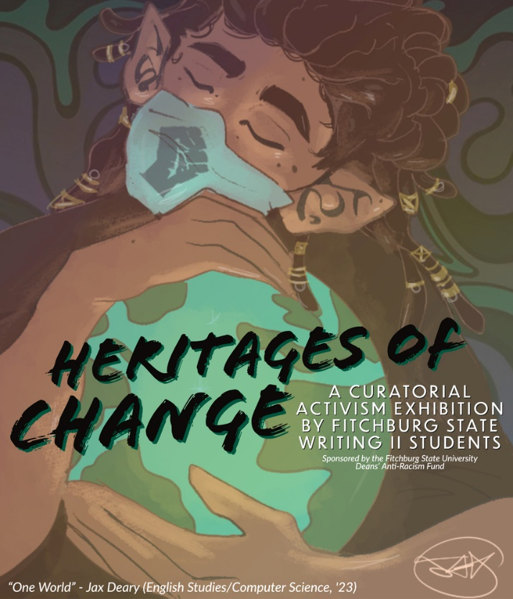
Dr. Tracy likes to focus on the authentic nature of the exhibit. In combining these assignments with anti-racist pedagogy, she hopes to show that students as individuals can have an impact, that their writing has an impact, and that all writing from anyone has an impact.
Heritages of Change student logo contest winner: “One World” by Jax Deary (English/Computer Science, '23)

“Would you say that’s your teaching philosophy?” I ask, as we wrap up our interview. She nods, “Yup, absolutely.”

